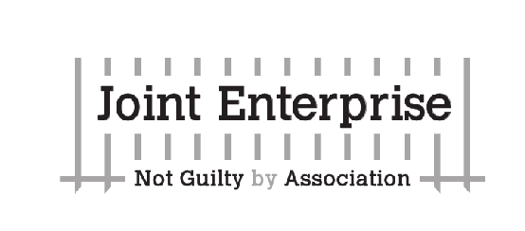JENGbA: Joint Enterprise: Not Guilty by Association
JENGbA (Joint Enterprise: Not Guilty by Association) is a grassroots campaign that was instrumental in helping The Supreme Court reach a landmark decision in February 2016 which acknowledged that Joint Enterprise had been misinterpreted by the courts for 32 years. This was a legal victory, vindication for all those who had campaigned that there was a serious problem with the law.
With this victory in mind we the undersigned believe the continued issues the JENGbA campaigners highlight merit the full attention and support of Parliament. We demand that the hundreds of men, women and children supported by JENGbA have their cases immediately reviewed by an independent judicial inquiry and that this is the only way to ensure that innocent people are not serving mandatory life sentences for crimes they did not commit.
Name | Address | email

